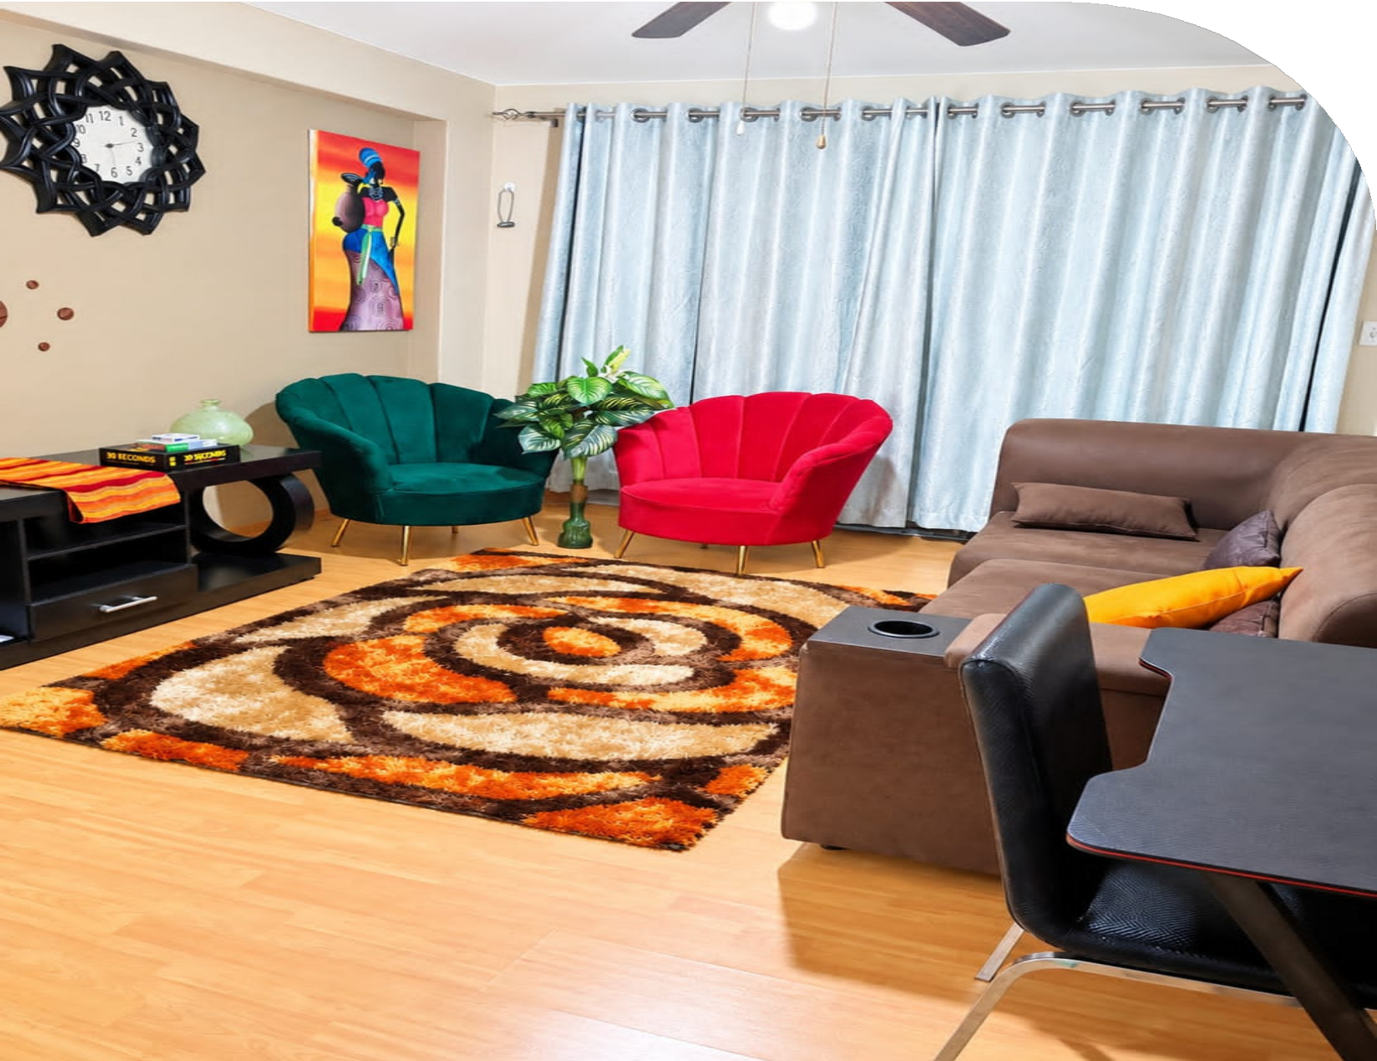
Richards Bay WileenWeide & Birdswood

ACCOMMODATION
The Great Escape
SPECIALS

free WIFI & fully furnished
R1350 2 bedroom cottage 5 sleeper R1250 2 bedroom apartment 4 sleeper R1600 3 bedroom apartment 6 sleeper

35% OFF

BOOK NOW
073 204 2608
www.escapetogreatness.com
thegreatescapehotel@gmail.com

