THE GREAT ESCAPE
RICHARDS BAY
WILD EN WEIDE & BIRDSWOOD

entire fully furnished apartments kitchen,living room, bathroom & bedrooms
PEAK SEASON PRICES
ACCOMMODATION

BOOK 2 NIGHTS & GET 1 FREE

6 SLEEPER R2900: 1KING 1 QUEEN 2 SINGLE (3 BEDROOM)
5 SLEEPER R2800: 1 KING 3 SINGLE (2 BEDROOM)
4 SLEEPER R2600: 1 QUEEN 2 SINGLE (2 BEDROOM)

BOOK NOW

073 204 2608
thegreatescapehotel@gmail.com www.escapetogreatness.com

Your paragraph text

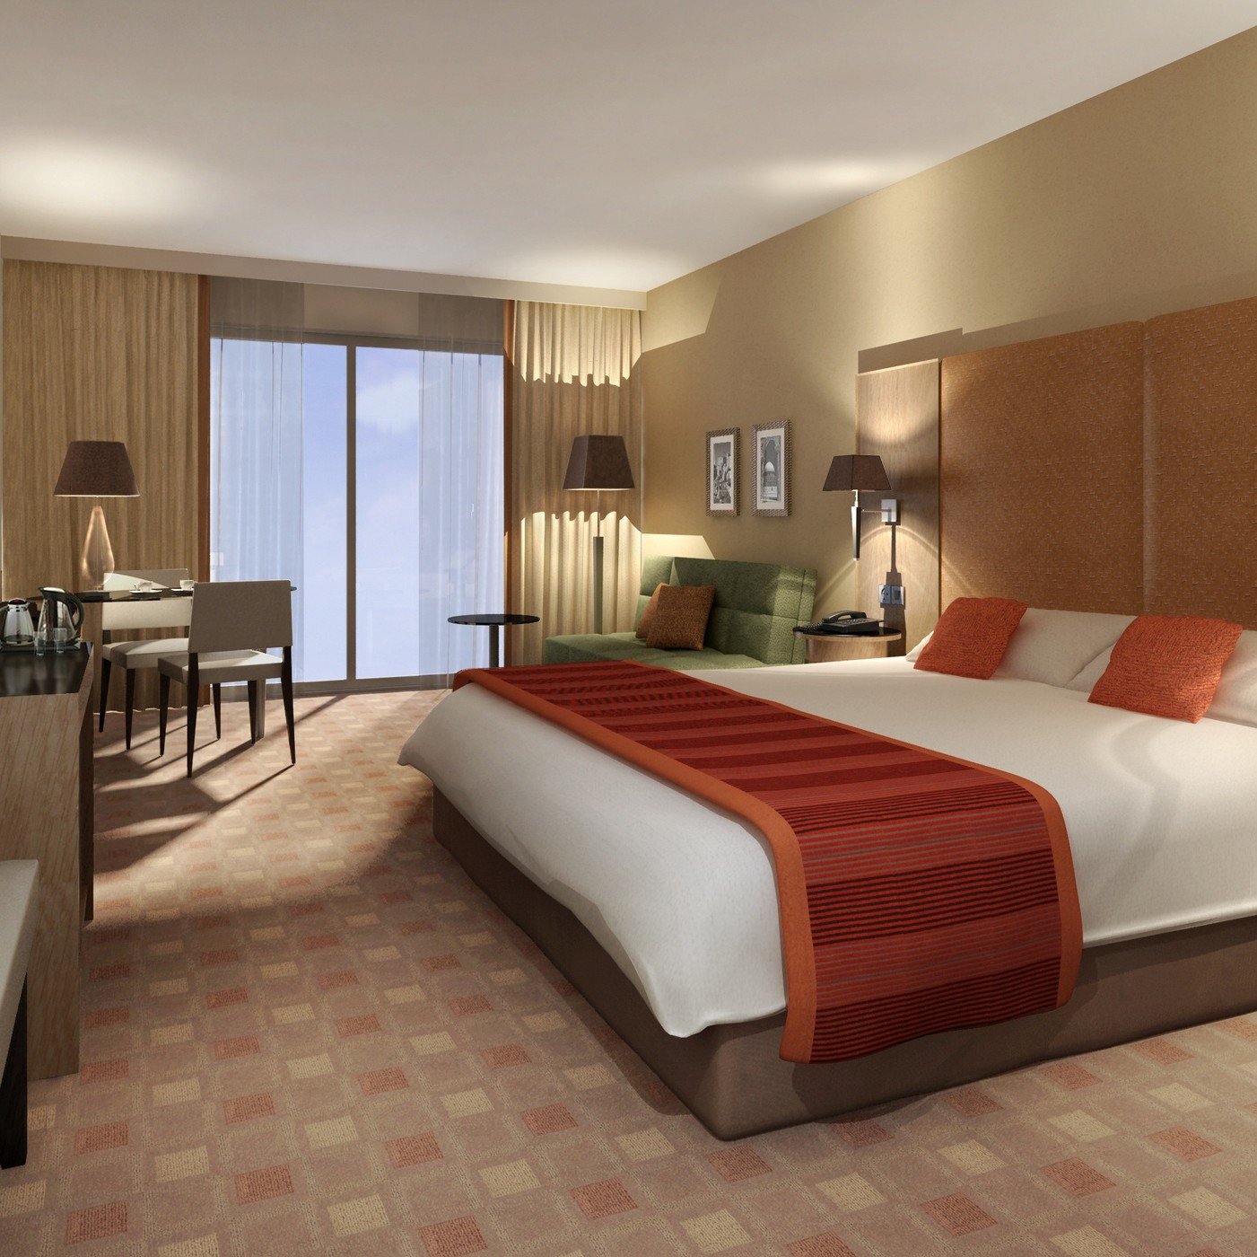
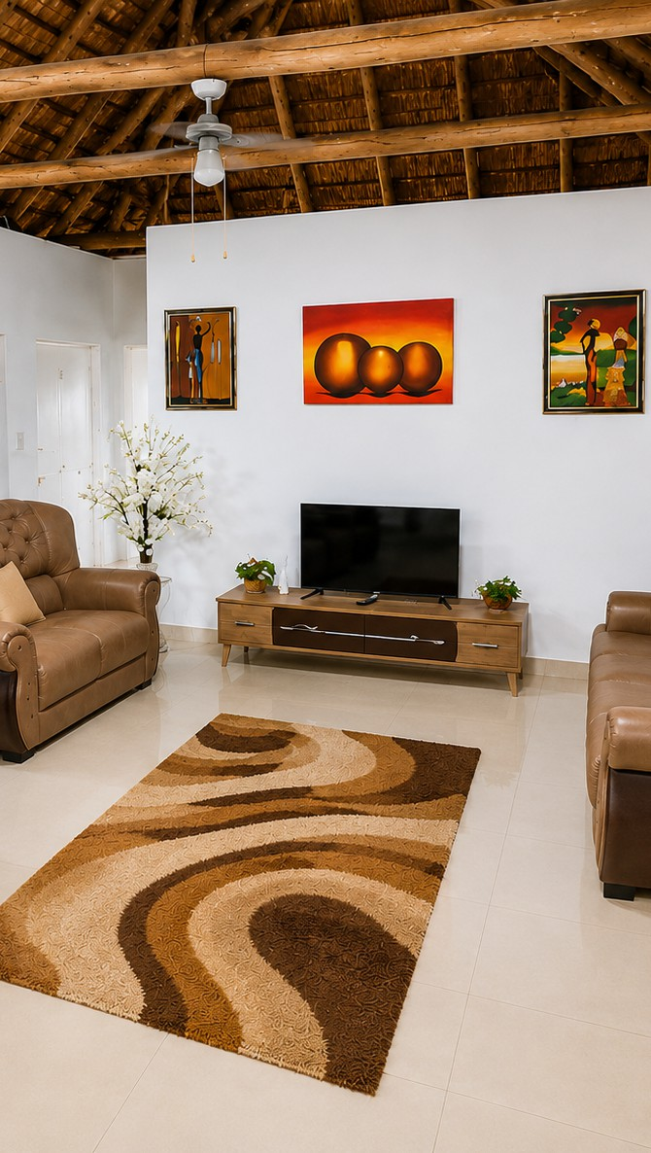
non-refundable policy apply for this promotion

BOOK 2 NIGHTS & GET 1 FREE

